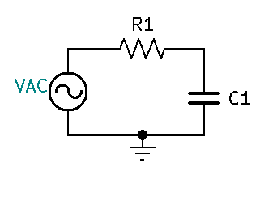Consider the following circuit:

At resonance or Fc, we know that:

$@ F_{C}, {XC}_{C1}=R1$

${XC}_{C1}=\frac{1}{2πFC1}$

$R1=\frac{1}{2πF_{C}C1}$

$F_{C}=\frac{1}{2πR1C1}$

Let’s assume that Vgen is equal to 10vp @ 1Khz, and ${XC}_{C1}$ and R1 both equal to 1KΩ respectively.

${XC}_{C1}=1KΩ ∠-90°$

$R1=1KΩ ∠0°$

* $ZT=\sqrt{{R1}^{2}+{{XC}_{C1}}^{2}}$, $∠\tan^{-1}{\frac{XC}{R}}$
  + $ZT=\sqrt{{1K}^{2}+{1K}^{2}}$, $∠\tan^{-1}{\frac{-1K}{1K}}$
  + $ZT=1.41421KΩ$**, $∠-45°$**

$IT= \frac{Vgen}{ZT}$

$IT= \frac{10vp∠0°}{1.4142KΩ∠-45°}$

$IT= 7.07114mA ∠45°$

$VR=IT ×R$

$VR=7.07114mA ∠45° ×1KΩ∠0°$

$VR=7.07114vp ∠45°$

$VC=IT ×{XC}_{C1}$

$VC=7.07114mA ∠45° ×1KΩ∠-90°$

$VC=7.07114vp ∠-45°$

With peak voltages and phase angles, we can calculate instantaneous voltages at any point with respect to time.

$V_{inst }= VmaxSin(360Ft± θ)$

${VGen}_{inst }= 10vpSin(360×1Khz×time± 0)$

${VR}_{inst }= 7.07vpSin(360×1Khz×time+45)$

${VC}_{inst }= 7.07vpSin(360×1Khz×time-45)$

